**Indian Education *District Wide* Spirit Days for 2024-2025**

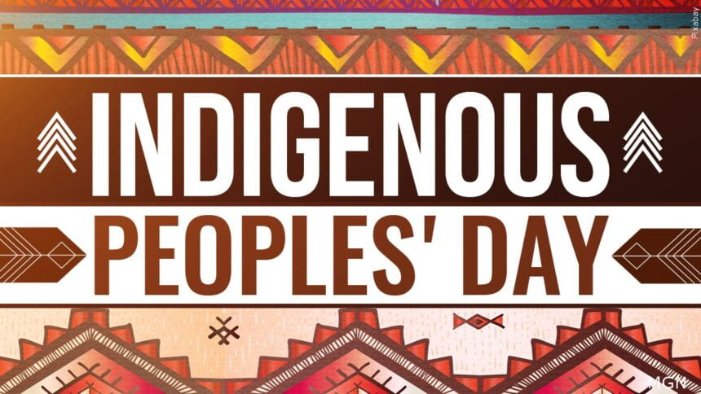

**Indigenous Peoples Day**

*honors the histories, cultures, and perspectives of Indigenous peoples and their ancestors who lived on the land now known as North America*

**Monday Oct 14th - Wear Orange**

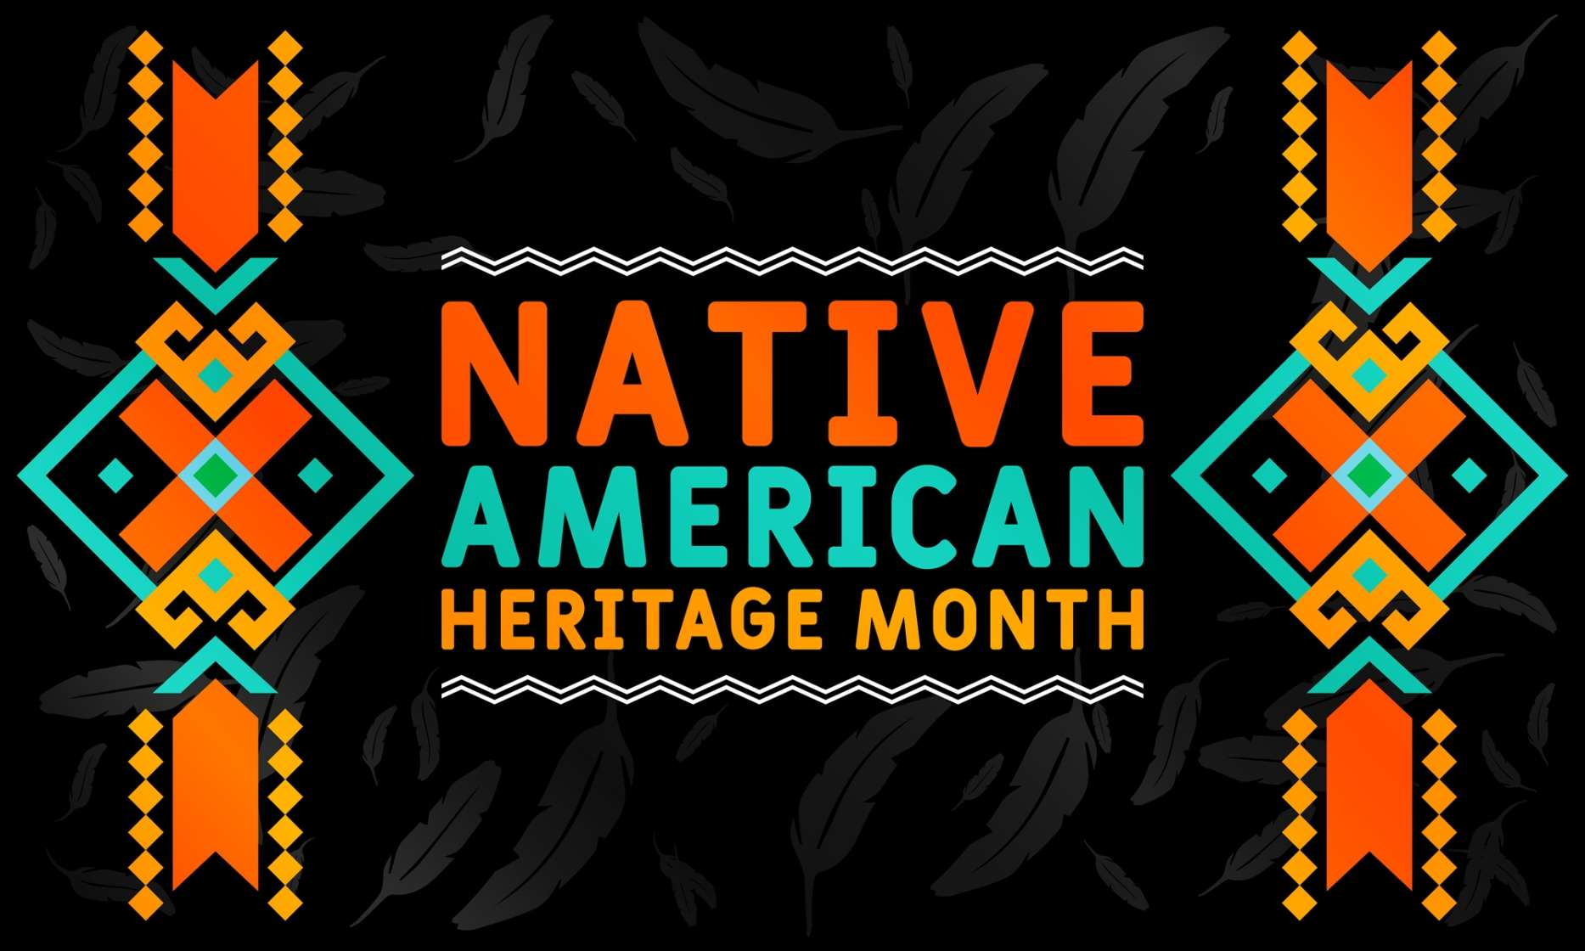

**Native American Heritage Spirit Week-** November 4 - 8, 2024

*\*School Dress code must be followed\**

Nov. 4 -Monday Jim Thorpe Sports Day (jersey or team shirt)

Nov. 5 -Tuesday Turtle Island Tuesday (wear green)

Nov. 6 -Wednesday Wampum Wednesday (wear purple)

Nov. 7 -Thursday Native American Attire (jewelry, clothes, moccasins)

Nov. 8 -Friday Back the Braids & Rep your tribe (hair braids, t-shirt with tribe name)

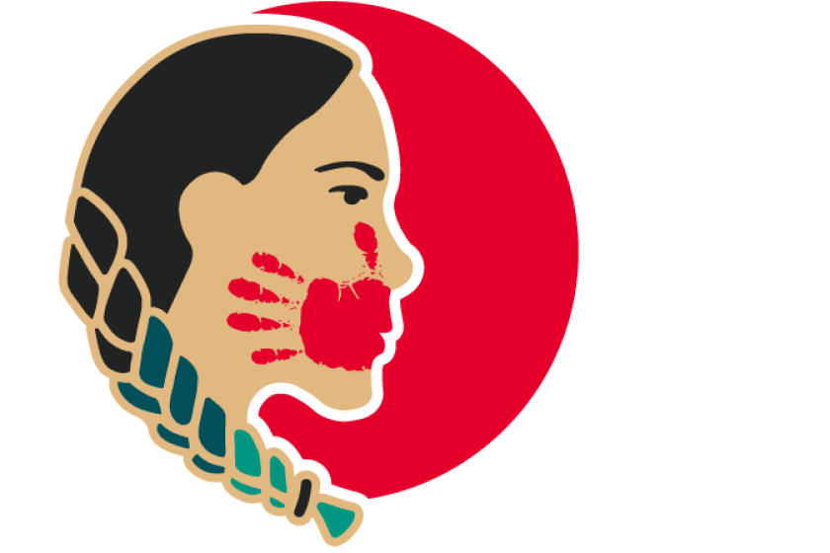

**MMIW Day**

*recognized across the United States and Canada as the National Awareness Day for Missing or Murdered Indigenous Women and Girls.*

**Monday May 5th - Wear Red**